***Start Screen***

The start screen should catch the players eye, every colour, element and detail used to draw the player in and keep them captivated, While most men don’t care for the aesthetics, woman are more attracted to things that “look pretty”.

Looking at some apps that have millions of players, I picked up on what makes them “good”, and that is the simplicity in the interface but detailed artwork.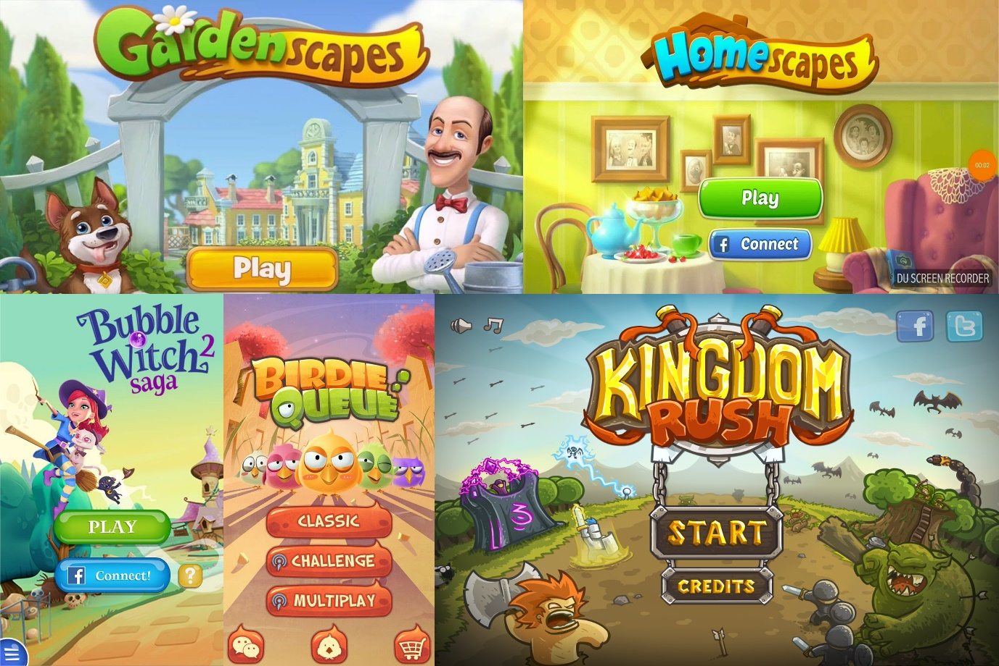

So, I came up with possible start screen designs: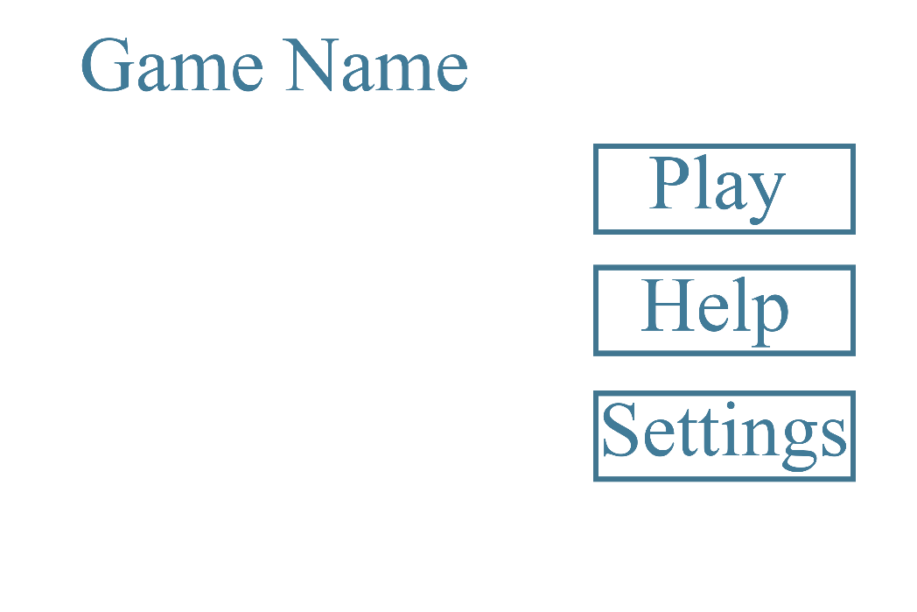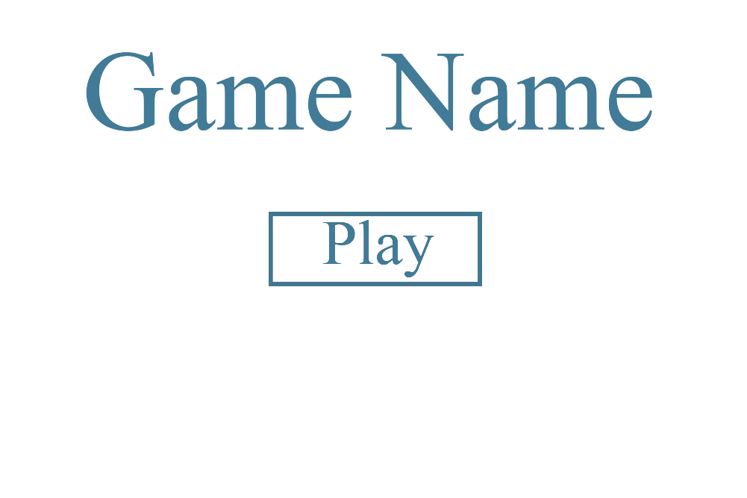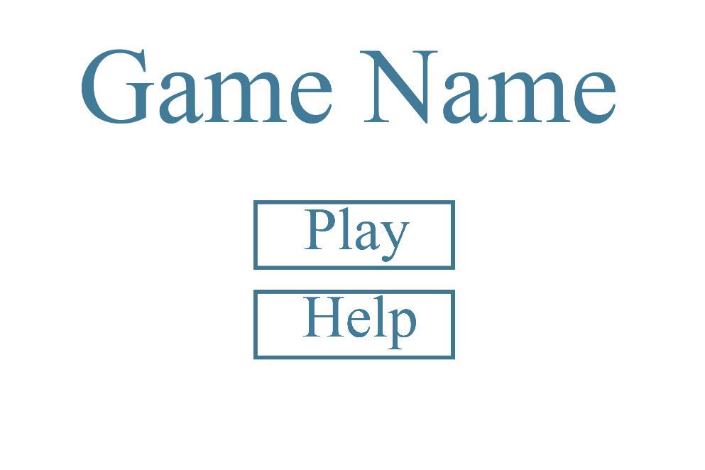

When the player presses play, I want the main focus to be on the game and the core of it. Therefore, the factory, houses and such should be easy to see and interact with. Unless we make the settings and different elements interactable.

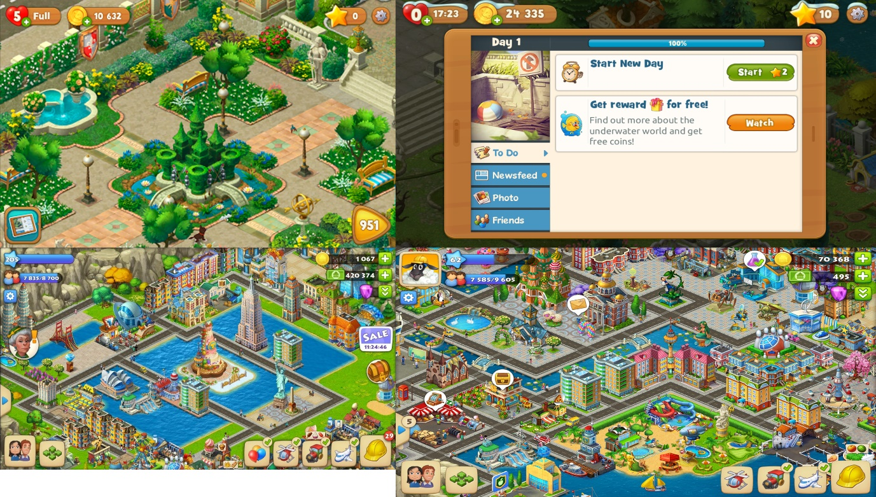

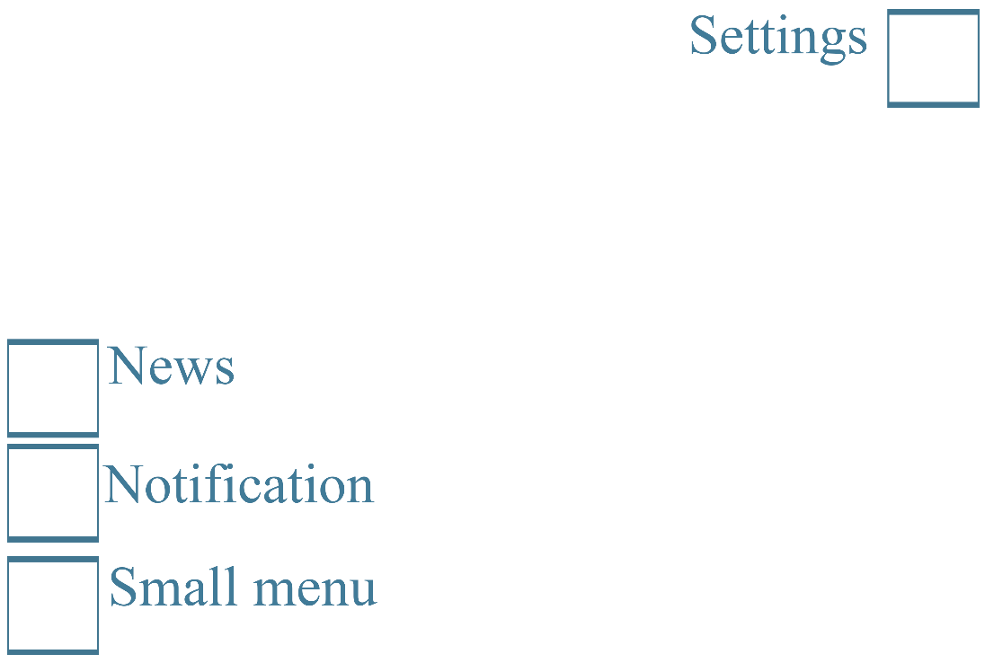

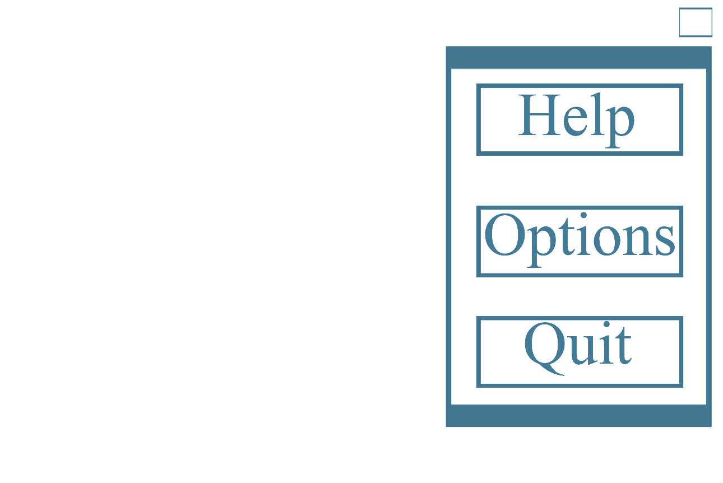

Concept work:

